

Name: How to configure a Twilio sim card

Author: Benoit Bideaux
Version: 1.0
Date of modification: 11/05/2023
Go to https://console.twilio.com/

Credentials available on KeyPass

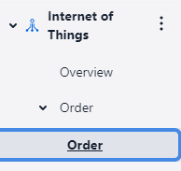 | How to order new sim cards  Go to Internet of things then click on Order.
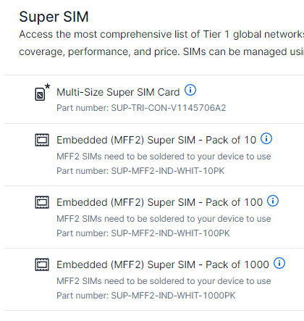 | Select the number of Super Sim required
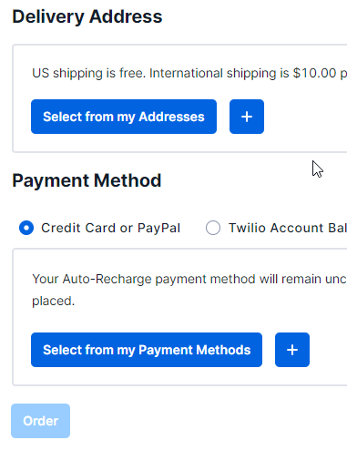 | Enter tour delivery address and credit card details.  Use Spendesk for getting a credit card  Then click on Order
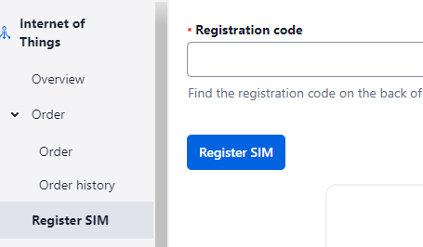 | How to register the sim cards  Go to Register SIM.  Enter the Sim number then click on Register SIM (20 digits)
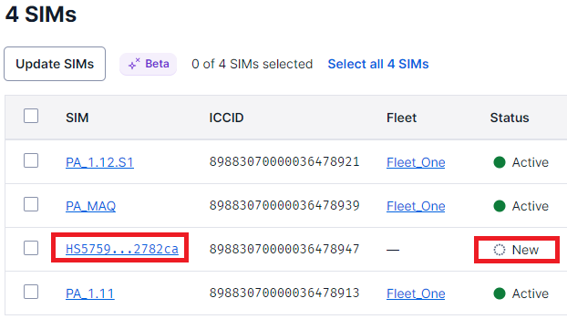 | How to activate a sim card  Go to Sim menu then click on an unactivated sim card
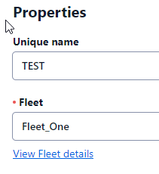 | Enter the name of the SIM card.  The name is defined by the soft/hardware teams first.  Select the Primary Fleet_One
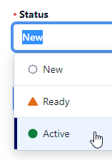 | Then select the status Active.  Then click on Save
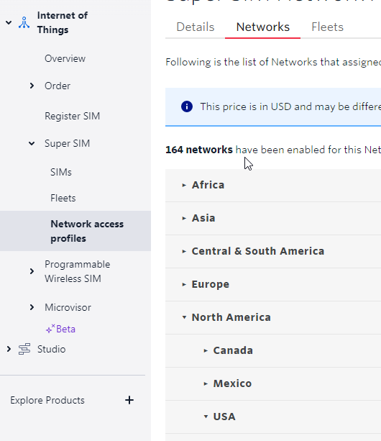 | How to add a country  Go to Super SIM then Network access profiles  Add the country then click Update Networks
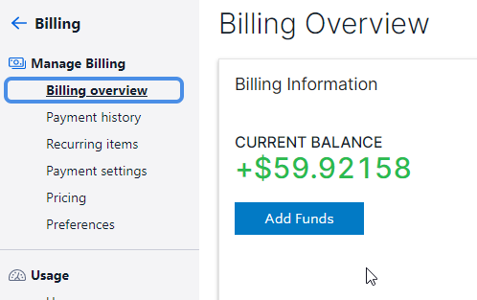 | How to add funds

