

Name: How to configure a Google group

Author: Benoit Bideaux
Version: 1.0
Date of modification: 17/05/2023
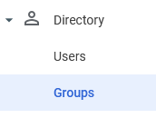 | From the Google Workspace console go to Directory then Groups
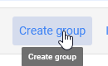 | Click on Create group
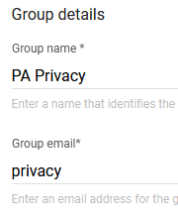 | Enter the name of the group and the email name.
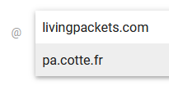 | Select the domain
 | Click on Next
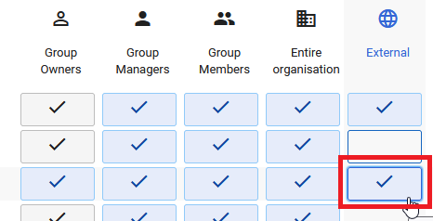 | If needed, open the group to external by clicking on the red option so the group is reachable by the external companies.  The opens can be changed later if needed.
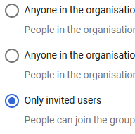 | Select the Only invited users option
 | Click on Create group
 | Click on Add members
 | Click on Add members
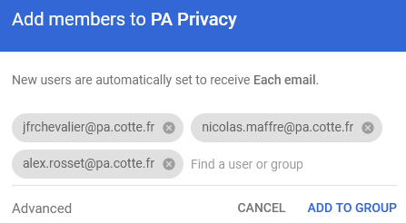 | Search for users then click on Add to Group
