

Name :
02b – Departure Forward Email

Author : Benoit Bideaux
Version : 1.0
Date of modification : 31/05/2023

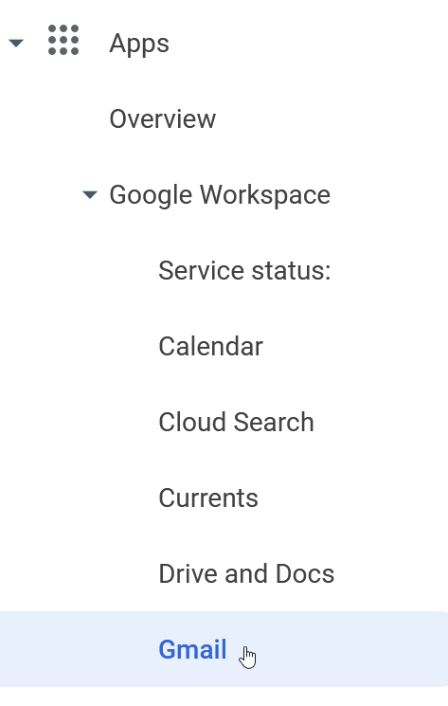 | Go to https://admin.google.com/ then log in with si@pa.cotte.fr account
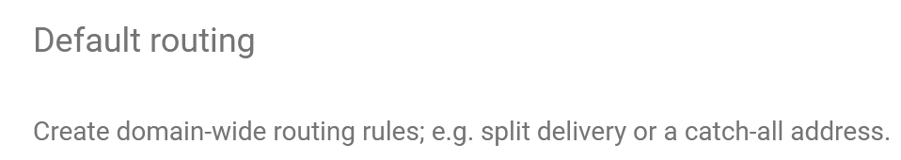 | Click on Default Routing menu
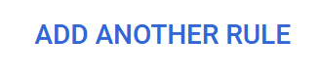 | Click on Add another rule

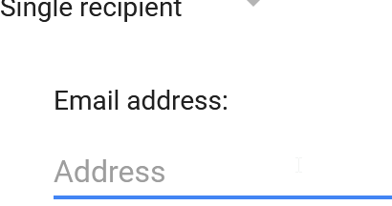 | Adding the email address to forward from.
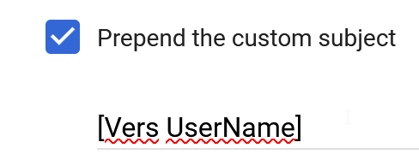 | Enable the prepend custom object by adding the username who left the company.  That helps to identify the recipient of the email.
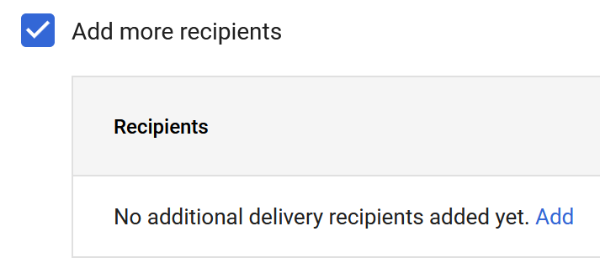 | Enable the more reccipents option.  click on Add
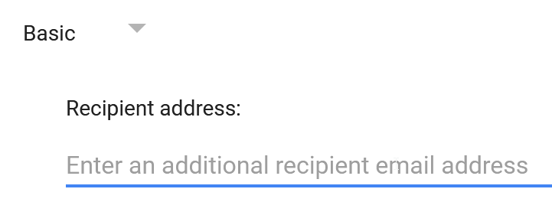 | Enter the email address of the user who should receive the email.  Click on Save

