

Name :
01c – New Arrival – How to create a new Active Directory account

Author : Benoit Bideaux
Version : 1.0
Date of modification : 24/09/2019

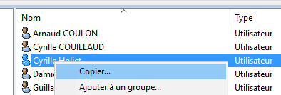 | From the correct OU, right-click on a User Object then click on Copier.
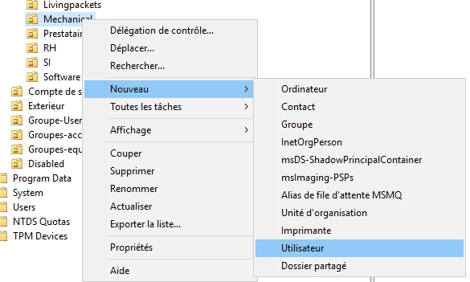 | If not, right-click from the OU itself, then click on Nouveau then select Utilisateur.
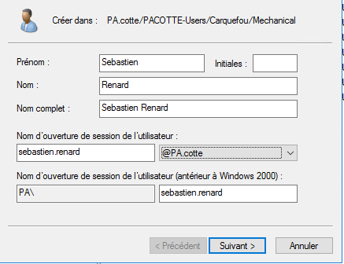 | Complete the information of the user  Click on Suivant
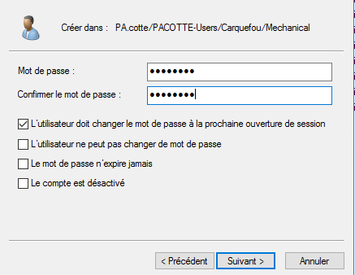 | Enter the password the click on Suivant  Active Directory & Gmail password must be the same.  Keep the 1st option ticked.
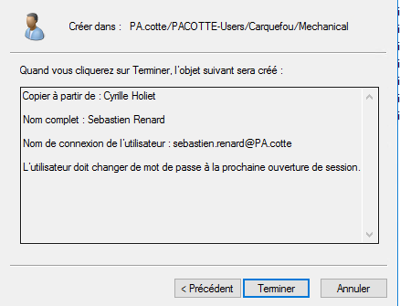 | Review the settings then click on Terminer
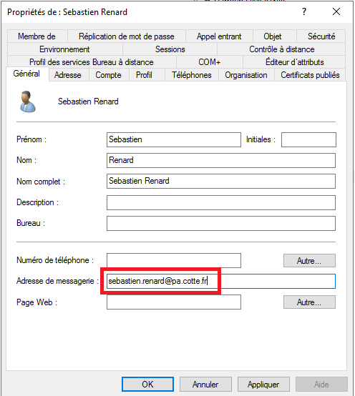 | Right-click on the User Object then add the email address.
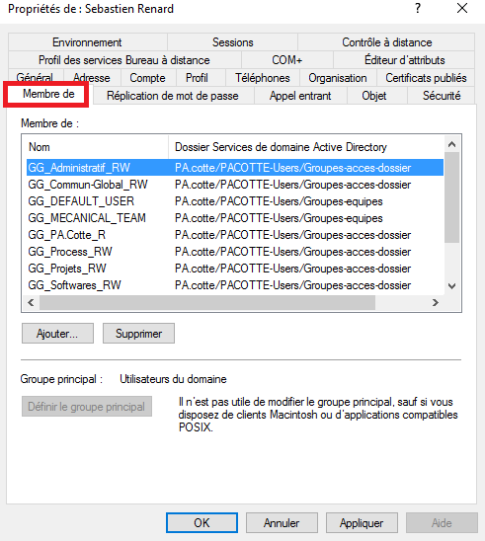 | Have a look on Membre de tab if needed then add the missing groups  Then click on Ok button
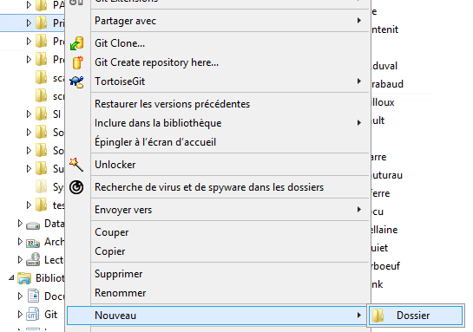 | Go to the files server.  Browse to E drive then Prives  Right-click on Prives then click on Nouveau then Dossier
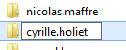

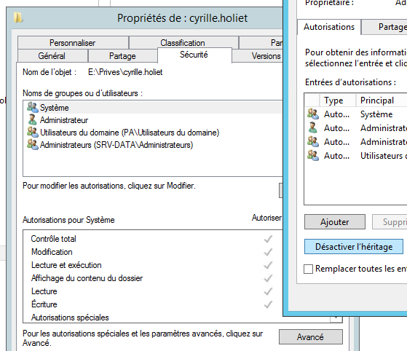 | Right-click, propriétés.  Go to Sécurité then click on Avancé  Then click on Désactiver l’héritage
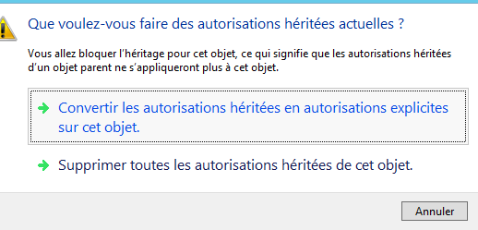 | Click on Convertir les autorisations héritées en autorisation explicites sur cet objet  Then click on Ok
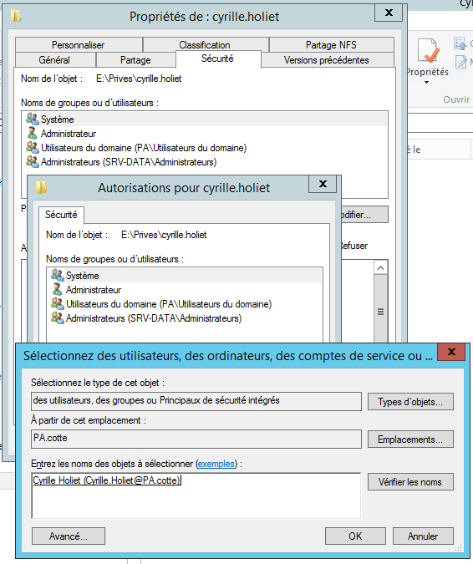 | Click on Modifier, then click on Ajouter.  Add the user account then click on Ok
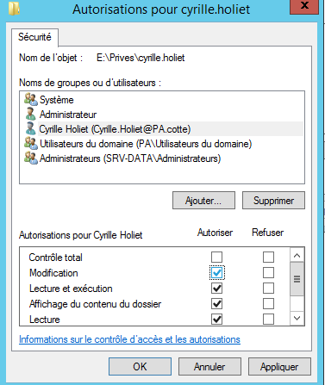 | Select the user and tick the option Modification.
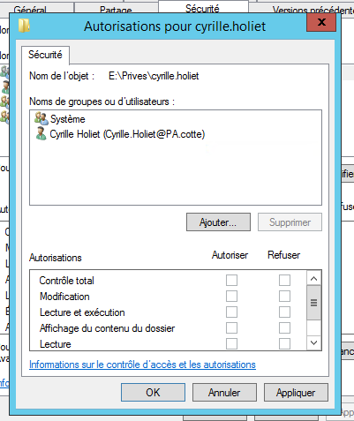 | Remove all others account except the user and Système  Then click on Ok  Then Click on Ok.
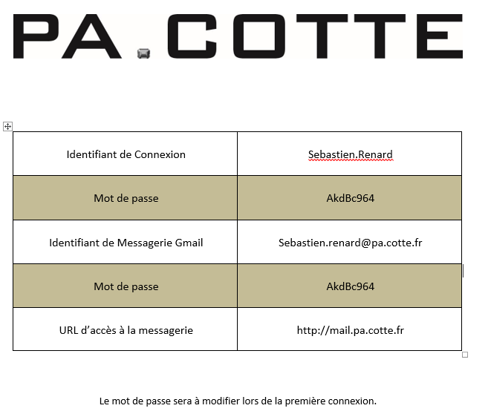 | Complete the « Identifiant de connexion » form.  This document must be secured until the document has been given to the user.

